# Alteration System Introduction

**Repository:** <https://github.com/jubayeralfarabi/alteration>

**Tools used**: Azure SQL Database, Azure Service Bus, Azure Application Insight, Azure AppService, Azure Function

#### **Swagger Url**

This repository includes 3 API services and 1 Azure Function written on c# .Net 6 and maintaining DDD architecture

**Alteration Service** : https://alterationapi.azurewebsites.net/swagger/index.html

**Payment Service** : <https://paymentapiservice.azurewebsites.net/swagger/index.html>

-- Here in MockOrderPaidCommand, RefId is the AlterationId and OrderId is just and Id.

**Notification Email Service** : https://emailapiservice.azurewebsites.net/swagger/index.html

#### **Run Locally**

Please change database connection string in all the appsettings because the given database connection string has IP restrictions.

### Common Folder Structure

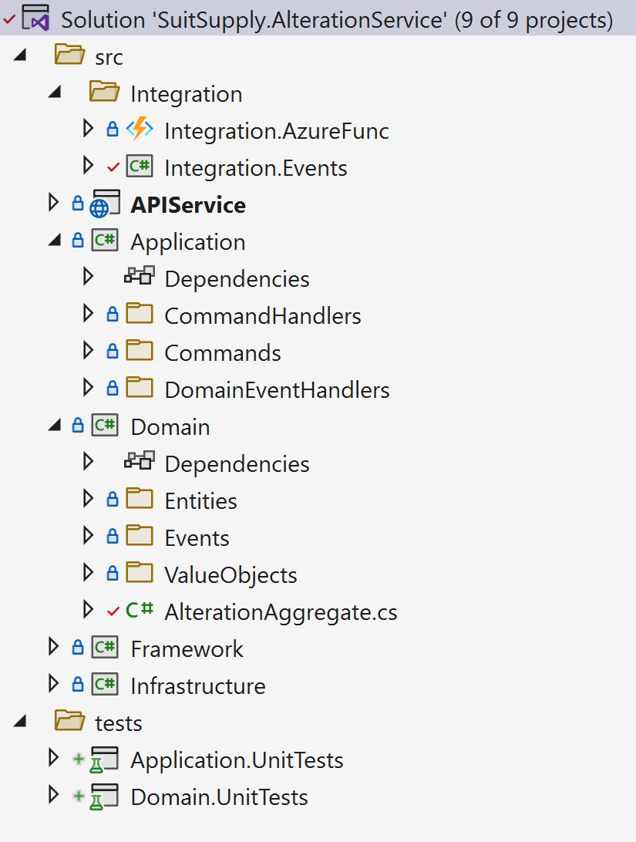

### Business Data Flow Diagram

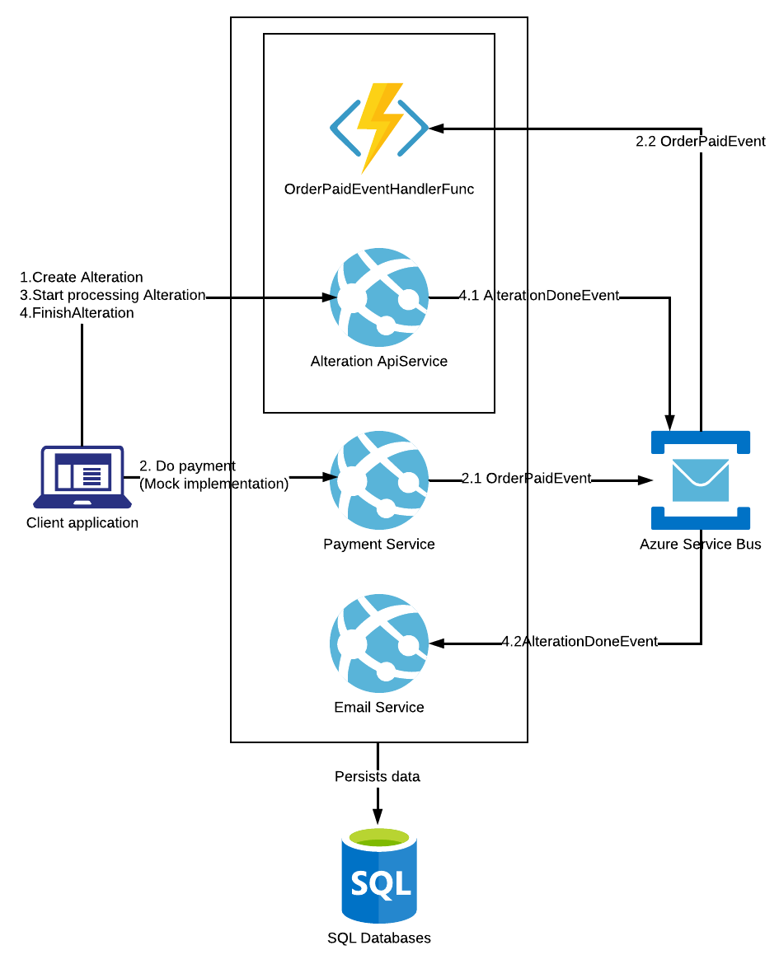

### Common Project Reference Diagram

